Documentation for Hikashop Accosapg Plugin Integration (Hikashop version : 2.3.5 and Joomla version: 3.x)

Steps for integration:

- Download the zip file i.e. accosapg.zip file.
- In Joomla administrator navigate to Extensions-> Extension Manager and upload the downloaded plugin.

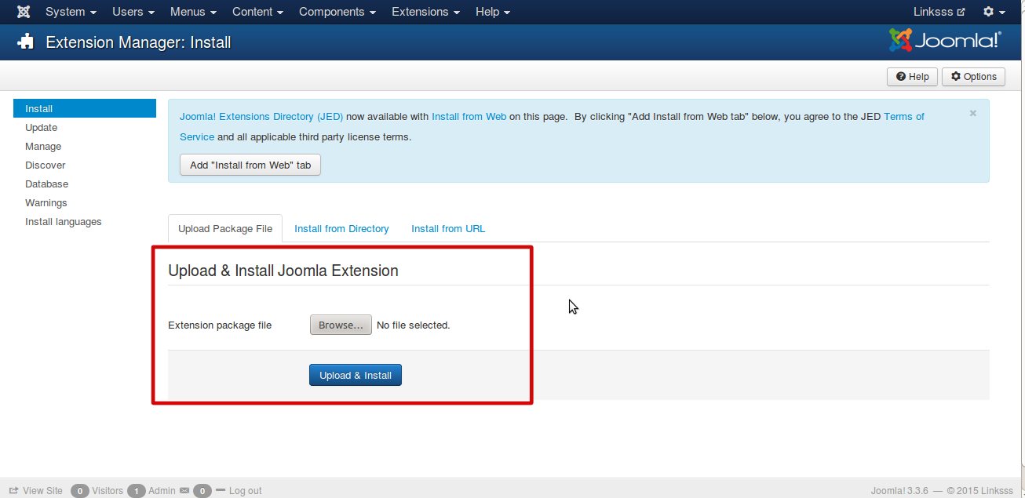
- Now Navigate to Components->HikaShop-> System-> Payment methods->New and select “Hikashop Accosapg Payment Plugin”.

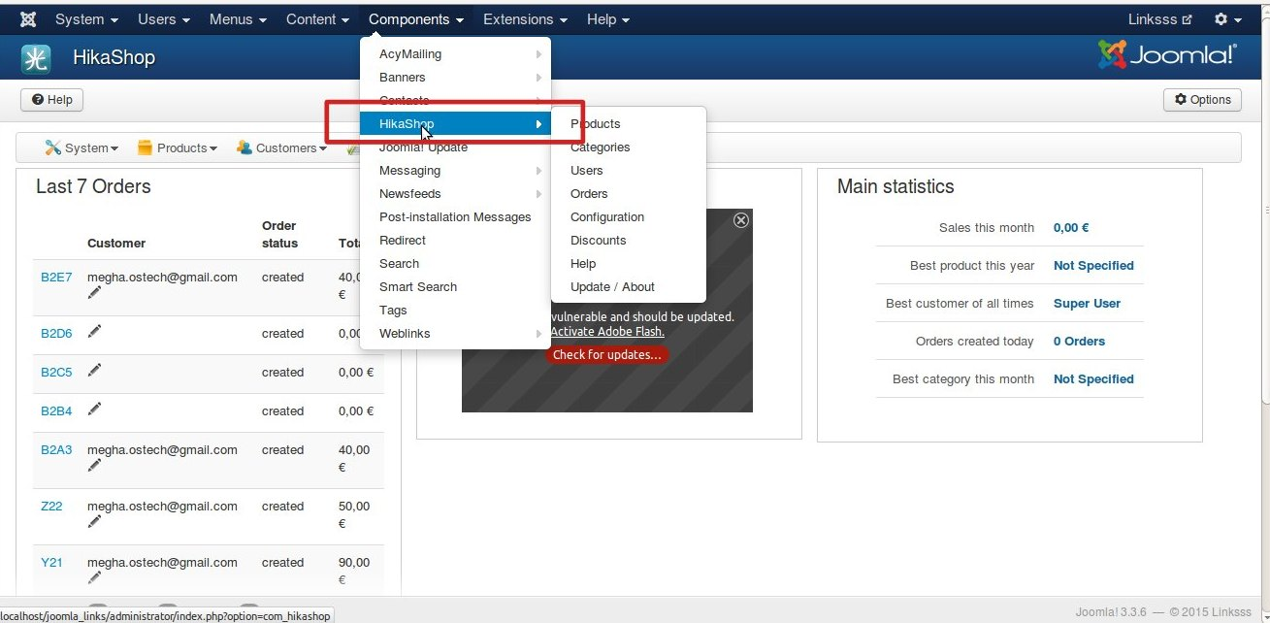

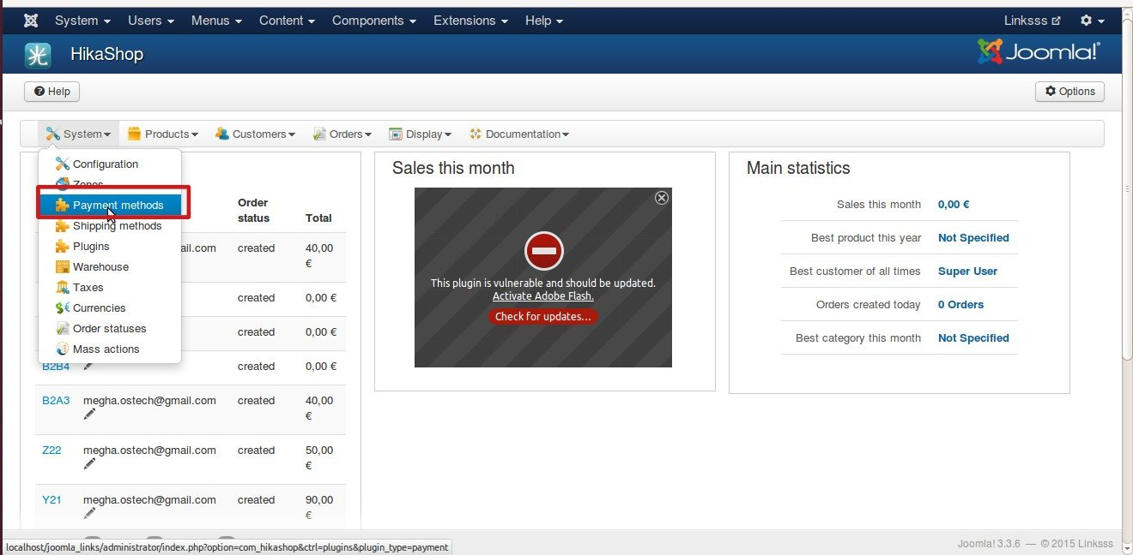

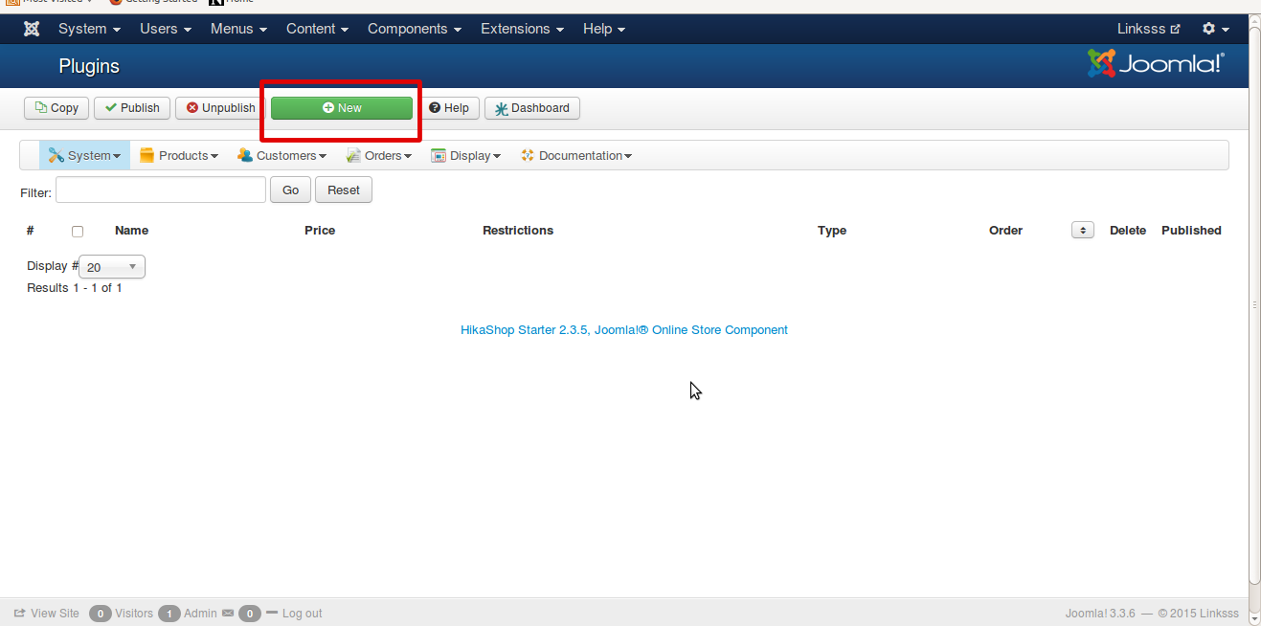

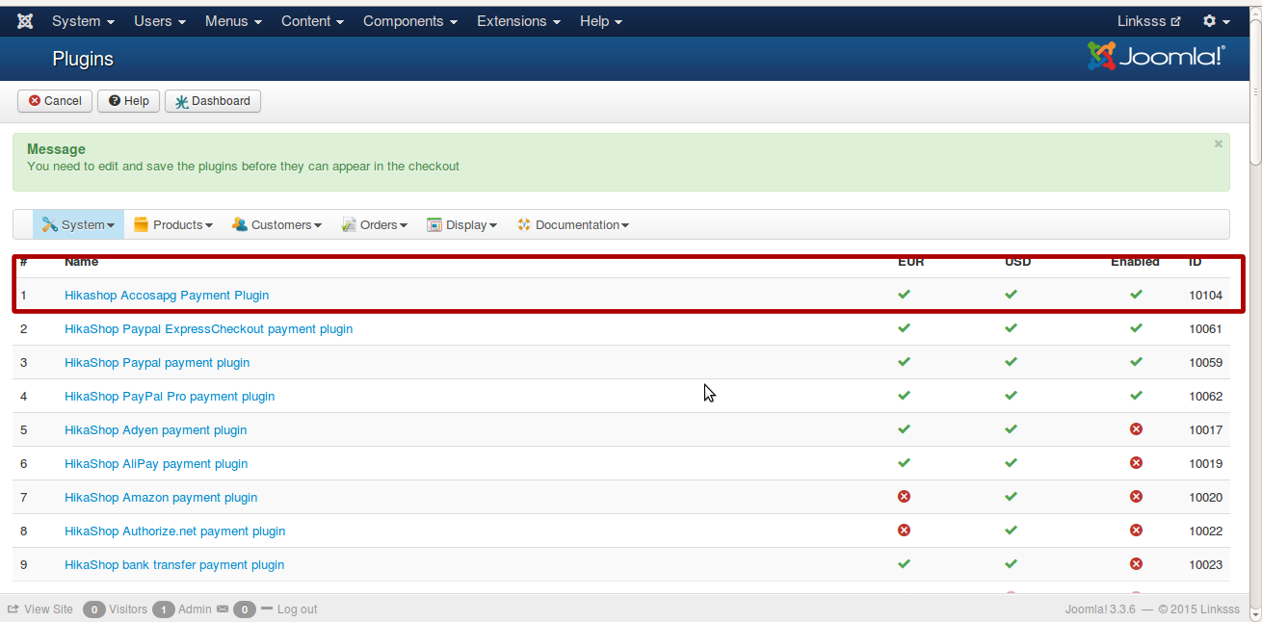

- Now fill the necessary information like name,description and Generic configuration like Images,Price etc according to your Hikashop default setting.

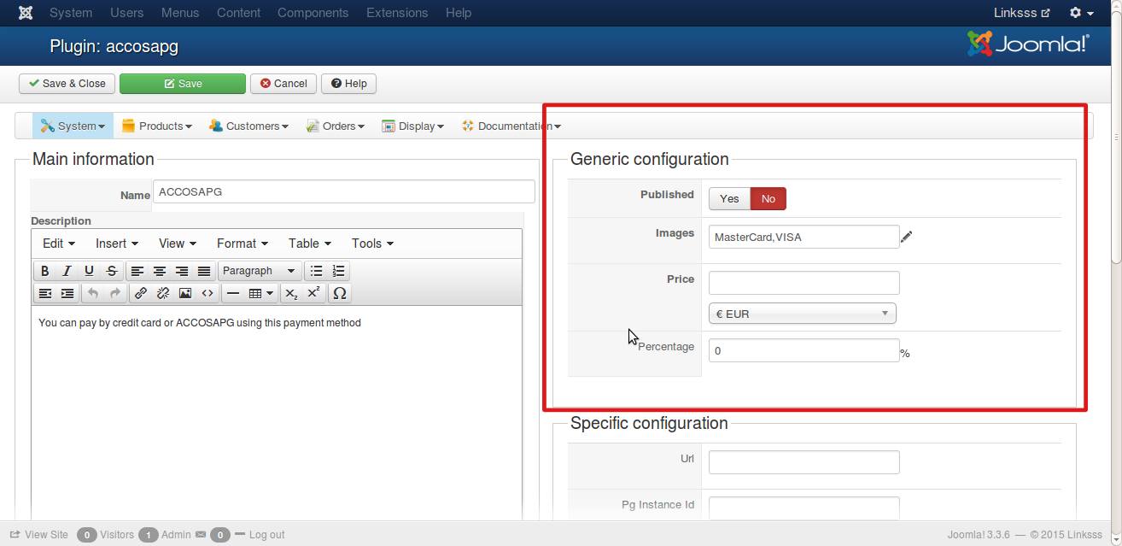

- Now for filling up Specific configuration admin should have Merchant account in “http://www.enstage.com/”
- After creating account in it they will provide us following detail :
Domain Url, Pg Instance Id, Merchant Id and Hash Key
- Also please ask your account pg admin of the Accosapg payment site that change your return url with following url:
YOUR_SITE_URL/index.php? option=com_hikashop&ctrl=checkout&task=notify&notif_payment=accosapg&tmpl=component&lang=en

- These detail should be filled in the Specific configuration of “Hikashop Accosapg Payment Plugin”.

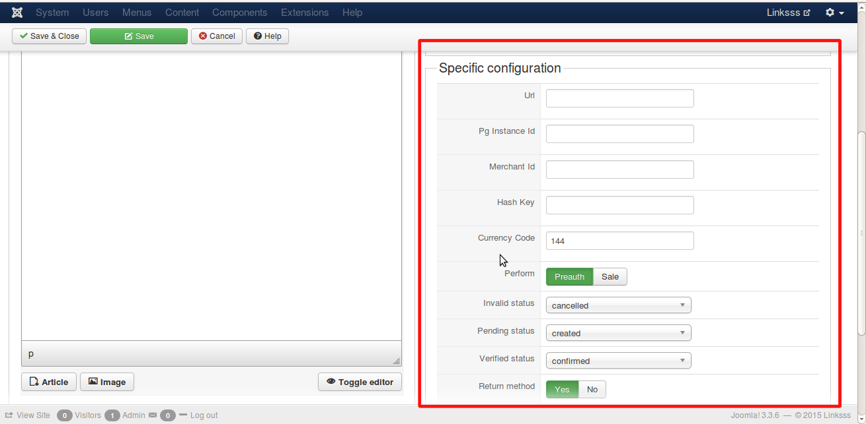

- After saving these information this payment plugin will be visible in frontend during payment method selection.

